H.T No
Regulations:
A17


Sreenidhi Institute of Science and Technology
(An Autonomous Institution)
Code No: 6B306 Date: 19-Nov-2018 (FN)

B.Tech II-Year I-Semester End External Examination, November - 2018 (Regular)
Mechanics of Solids (ME)

Time: 3 Hours Max.Marks:75

Note: a) No additional answer sheets will be provided.
b) All sub-parts of a question must be answered at one place only, otherwise it will not be valued.
c) Missing data can be assumed suitably.

Part - A Max.Marks:25

Answer all QUESTIONS.

1. | Draw tensile test diagram for steel. Explain its salient features. | [3M]
2. | Calculate the power that can be transmitted at a 300rpm by a hollow steel shaft of 75mm external diameter and 50mm internal diameter, when the permissible shear stress for the steel is 70N/mm² and the maximum torque is 1.3 times the mean torque. | [3M]
3. | A simple beam of length L is subjected is subjected to a point load ‘W’ at mid span. Find maximum bending moment. | [3M]
4. | Define section modulus and find section modulus for a solid circular beam of diameter ‘d’. | [3M]
5. | Find slope and deflection for a cantilever beam of length L carrying a load ‘W’ at free end. | [3M]
6. | What are the assumptions made in the thin spherical shells? | [2M]
7. | Define Poisson’s ratio. Write the expressions for strains in the three principal planes. | [2M]
8. | What are sagging and hogging bending moment. | [2M]
9. | What is Euler’s curve? What is its importance? | [2M]
10. | Write the expressions of circumferential and longitudinal strains in a cylinder. | [2M]
Part – B Max.Marks:50
ANSWER ANY FIVE QUESTIONS. EACH QUESTION CARRIES 10 MARKS.

11. | a) | Explain the terms true stress, true strain, Engineering stress and Engineering strain. | [4M]
 | b) | A rigid bar that is supported by a pin A and two rods one made of steel and other of bronze. Neglecting the weight of the bar compute the stresses in each rod caused by 50 kN load . Take young’s modulus and cross section areas of steel and bronze as 205GPa, 600 mm² and 83GPa, 200 mm² respectively.  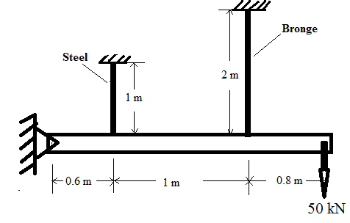 | [6M]
12. | a) | At a point in a strained material, the principal stresses are100 N/mm² (Tensile) and 40 N/mm² (Compression). Determine the resultant stress in magnitude and direction in a plane inclined at 60⁰ to the axis of major principal stress. What is the maximum intensity of shear stress in the material at the point? | [5M]
 | b) | Define the terms: torsion, torsional rigidity and polar moment of inertia. | [5M]
13. |  | A cantilever beam of length 5m carries a point loads as shown in Fig. Draw shear force and bending moment diagram.  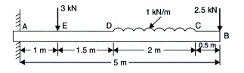 | [10M]
14. |  | The shear force acting on a I-section of a beam shown in the Fig is 50 kN . Find the maximum shear stress developed in the I- section. Also draw the shear stress distribution over the depth of the section. Take I= 2.849 x 10⁴ mm⁴ about N.A.  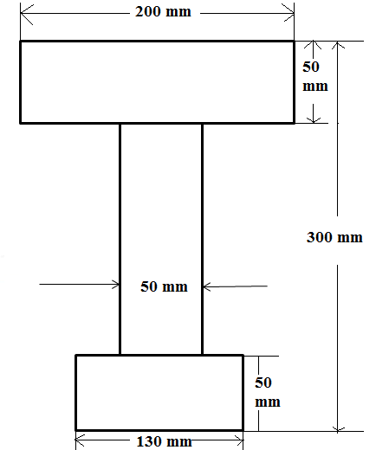 | [10M]
15. |  | A cantilever of length 3 m carries two point loads of 2 KN at the free end and 4 KN at a distance of 1 m from the free end. Find the deflection at the free end. Take E= 2 x 10⁵ N/mm² and I=10⁸ mm⁴. | [10M]
16. |  | A vessel in the shape of a spherical shell of 1.20 m internal diameter and 12 mm shell thickness is subjected to pressure of 1.6 N/mm² . Determine the stress induced in the material of the vessel and also Find the change in dimensions of shell. Take E= 2x 10⁵ N/mm² , µ or 1/m = 0.33 . | [10M]
17. | a) | A 60mm diameter shaft is subjected to a torque of 4 KN-M, Find (i) maximum shear stress induced in the shaft (ii) Angle of twist per meter length of the shaft (iii) shear stress at a distance of 10 mm from the axis of the shaft. Take G=8x10⁴ N/mm^{2.} | [6M]
 | b) | What is a compound bar? Derive the equation for change in length of a compound bar subjected to an axial tensile force’ P’. | [4M]
18. | a) | Derive an expression for radial pressure and hoop stress for a thick cylindrical shell. | [4M]
 | b) | What do you mean by end conditions of a column? What are the important end conditions for a column? Explain them. | [4M]
 | c) | What are the assumptions made in the Lame’s equation? | [2M]

-- 00 -- 00 –

